Dimensional Model
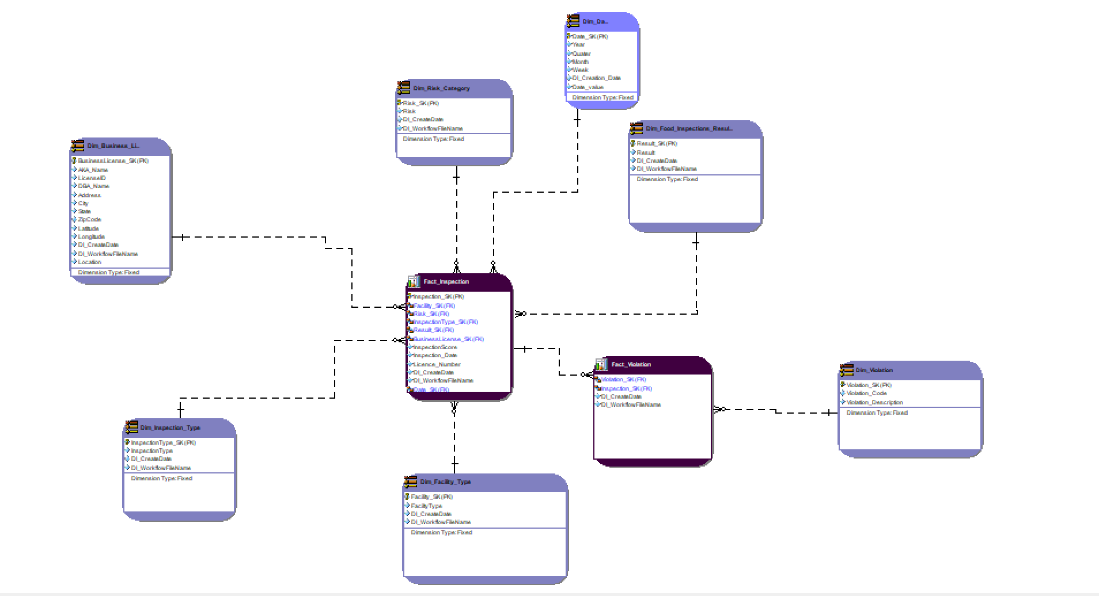

Fact Tables:
- There are two fact tables – Inspection and Violation
Dimensions:
- There are seven dimensions connected to the fact tables – Business License, Inspection Type, Facility Type, Violation, Date, Risk Category and Food Inspection Results.
Schema:
- The dimensional model is designed using a star schema

DDL SQL SCRIPT GENERATED FROM ER STUDIO
/*
* ER/Studio Data Architect SQL Code Generation
* Project : DimensionModel_Midterm.DM1
*
* Date Created : Sunday, February 25, 2024 06:28:00
* Target DBMS : Microsoft SQL Server 2019
*/

USE midterm_project
go
/*
* TABLE: Dim_Business_License
*/

CREATE TABLE Dim_Business_License(
BusinessLicense_SK int NOT NULL,
AKA_Name char(10) NULL,
LicenseID int NULL,
LegalName varchar(255) NULL,
DBA_Name varchar(255) NULL,
Address varchar(255) NULL,
City varchar(255) NULL,
State varchar(255) NULL,
ZipCode varchar(255) NULL,
Latitude real NULL,
Longitude real NULL,
DI_CreateDate date NULL,
DI_WorkflowFileName varchar(255) NULL,
Location varchar(255) NULL,
CONSTRAINT PK5 PRIMARY KEY NONCLUSTERED (BusinessLicense_SK)
)

go

IF OBJECT_ID('Dim_Business_License') IS NOT NULL
PRINT '<<< CREATED TABLE Dim_Business_License >>>'
ELSE
PRINT '<<< FAILED CREATING TABLE Dim_Business_License >>>'
go

/*
* TABLE: Dim_Date
*/

CREATE TABLE Dim_Date(
Date_SK char(10) NOT NULL,
Year char(10) NULL,
Quater char(10) NULL,
Month char(10) NULL,
Week char(10) NULL,
DI_Creation_Date char(10) NULL,
DI_workflowFileName char(10) NULL,
CONSTRAINT PK11 PRIMARY KEY NONCLUSTERED (Date_SK)
)

go

IF OBJECT_ID('Dim_Date') IS NOT NULL
PRINT '<<< CREATED TABLE Dim_Date >>>'
ELSE
PRINT '<<< FAILED CREATING TABLE Dim_Date >>>'
go

/*
* TABLE: Dim_Facility_Type
*/

CREATE TABLE Dim_Facility_Type(
Facility_SK int NOT NULL,
FaciltyType varchar(255) NULL,
DI_CreateDate datetime NULL,
DI_WorkflowFileName varchar(255) NULL,
CONSTRAINT PK10 PRIMARY KEY NONCLUSTERED (Facility_SK)
)

go

IF OBJECT_ID('Dim_Facility_Type') IS NOT NULL
PRINT '<<< CREATED TABLE Dim_Facility_Type >>>'
ELSE
PRINT '<<< FAILED CREATING TABLE Dim_Facility_Type >>>'
go

/*
* TABLE: Dim_Food_Inspections_Results
*/

CREATE TABLE Dim_Food_Inspections_Results(
Result_SK int NOT NULL,
Result varchar(255) NULL,
DI_CreateDate date NULL,
DI_WorkflowFileName varchar(255) NULL,
CONSTRAINT PK8 PRIMARY KEY NONCLUSTERED (Result_SK)
)

go

IF OBJECT_ID('Dim_Food_Inspections_Results') IS NOT NULL
PRINT '<<< CREATED TABLE Dim_Food_Inspections_Results >>>'
ELSE
PRINT '<<< FAILED CREATING TABLE Dim_Food_Inspections_Results >>>'
go

/*
* TABLE: Dim_Inspection_Type
*/

CREATE TABLE Dim_Inspection_Type(
InspectionType_SK int NOT NULL,
InspectionType varchar(255) NULL,
DI_CreateDate datetime NULL,
DI_WorkflowFileName varchar(255) NULL,
CONSTRAINT PK1 PRIMARY KEY NONCLUSTERED (InspectionType_SK)
)

go

IF OBJECT_ID('Dim_Inspection_Type') IS NOT NULL
PRINT '<<< CREATED TABLE Dim_Inspection_Type >>>'
ELSE
PRINT '<<< FAILED CREATING TABLE Dim_Inspection_Type >>>'
go

/*
* TABLE: Dim_Risk_Category
*/

CREATE TABLE Dim_Risk_Category(
Risk_SK int NOT NULL,
Risk varchar(255) NULL,
DI_CreateDate datetime NULL,
DI_WorkflowFlieName varchar(255) NULL,
CONSTRAINT PK3 PRIMARY KEY NONCLUSTERED (Risk_SK)
)

go

IF OBJECT_ID('Dim_Risk_Category') IS NOT NULL
PRINT '<<< CREATED TABLE Dim_Risk_Category >>>'
ELSE
PRINT '<<< FAILED CREATING TABLE Dim_Risk_Category >>>'
go

/*
* TABLE: Dim_Violation
*/

CREATE TABLE Dim_Violation(
Violation_SK int NOT NULL,
Violation_Code varchar(255) NULL,
Violation_Description varchar(255) NULL,
Violation_Comment varchar(255) NULL,
version varchar(255) NULL,
CONSTRAINT PK9 PRIMARY KEY NONCLUSTERED (Violation_SK)
)

go

IF OBJECT_ID('Dim_Violation') IS NOT NULL
PRINT '<<< CREATED TABLE Dim_Violation >>>'
ELSE
PRINT '<<< FAILED CREATING TABLE Dim_Violation >>>'
go

/*
* TABLE: Fact_Inspection
*/

CREATE TABLE Fact_Inspection(
Inspection_SK int NOT NULL,
Facility_SK int NOT NULL,
Risk_SK int NOT NULL,
InspectionType_SK int NOT NULL,
Result_SK int NOT NULL,
BusinessLicense_SK int NOT NULL,
InspectionScore varchar(255) NULL,
Inspection_Date date NULL,
Licence_Number varchar(255) NULL,
DI_CreateDate datetime NULL,
DI_WorkflowFileName varchar(255) NULL,
Date_SK char(10) NOT NULL,
CONSTRAINT PK2 PRIMARY KEY NONCLUSTERED (Inspection_SK)
)

go

IF OBJECT_ID('Fact_Inspection') IS NOT NULL
PRINT '<<< CREATED TABLE Fact_Inspection >>>'
ELSE
PRINT '<<< FAILED CREATING TABLE Fact_Inspection >>>'
go

/*
* TABLE: Fact_Violation
*/

CREATE TABLE Fact_Violation(
FactViolationSK int NOT NULL,
Violation_SK int NOT NULL,
Inspection_SK int NOT NULL,
Violation_Points varchar(255) NULL,
DI_CreateDate date NULL,
DI_WorkflowFileName varchar(255) NULL,
CONSTRAINT PK7 PRIMARY KEY NONCLUSTERED (FactViolationSK)
)

go

IF OBJECT_ID('Fact_Violation') IS NOT NULL
PRINT '<<< CREATED TABLE Fact_Violation >>>'
ELSE
PRINT '<<< FAILED CREATING TABLE Fact_Violation >>>'
go

/*
* TABLE: Fact_Inspection
*/

ALTER TABLE Fact_Inspection ADD CONSTRAINT RefDim_Risk_Category2
FOREIGN KEY (Risk_SK)
REFERENCES Dim_Risk_Category(Risk_SK)
go

ALTER TABLE Fact_Inspection ADD CONSTRAINT RefDim_Business_License4
FOREIGN KEY (BusinessLicense_SK)
REFERENCES Dim_Business_License(BusinessLicense_SK)
go

ALTER TABLE Fact_Inspection ADD CONSTRAINT RefDim_Food_Inspections_Results6
FOREIGN KEY (Result_SK)
REFERENCES Dim_Food_Inspections_Results(Result_SK)
go

ALTER TABLE Fact_Inspection ADD CONSTRAINT RefDim_Facility_Type7
FOREIGN KEY (Facility_SK)
REFERENCES Dim_Facility_Type(Facility_SK)
go

ALTER TABLE Fact_Inspection ADD CONSTRAINT RefDim_Date11
FOREIGN KEY (Date_SK)
REFERENCES Dim_Date(Date_SK)
go

ALTER TABLE Fact_Inspection ADD CONSTRAINT RefDim_Inspection_Type1
FOREIGN KEY (InspectionType_SK)
REFERENCES Dim_Inspection_Type(InspectionType_SK)
go

/*
* TABLE: Fact_Violation
*/

ALTER TABLE Fact_Violation ADD CONSTRAINT RefFact_Inspection9
FOREIGN KEY (Inspection_SK)
REFERENCES Fact_Inspection(Inspection_SK)
go

ALTER TABLE Fact_Violation ADD CONSTRAINT RefDim_Violation10
FOREIGN KEY (Violation_SK)
REFERENCES Dim_Violation(Violation_SK)
go

